# Material Summary: Basic Algebra

## 1. Polynomials

* **Мonomial (едночлен): $2x^{2}$** Coefficient (number), variable, power (number $≥0$)
* **Polynomial (многочлен)**: $2x^{4}+3x^{2}−0,5x+2,72$ sum of monomials

## 2. Polynomials in Python

import numpy.polynomial.polynomial as p

p.polyadd([-8, 5, 2], [-2, 0, 0, 0, 3])

p.polymul([-8, 5, 2], [-2, 0, 0, 0, 3])

# array([-10., 5., 2., 0., 3.])

# array([ 16., -10., -4., 0., -24., 15., 6.])

* **Pretty printing:** Use **sympy** to print the polynomial. **Reverse** the order of coefficients (sympy expects them from highest to lowest)

import sympy

from sympy.abc import x

polynomial = p.Polynomial([-2, 0, 0, 0, 3])

sympy.init_printing()

print(sympy.Poly(reversed(polynomial.coef), x).as_expr())

# Output: 3.0*x**4 - 2.0

## 3. Set

* An **unordered collection** of **unique** things
* **Set notation**:
  + Python **set comprehensions**: very similar to list comprehensions (but with curly braces)

positive_x = {x for x in range(-5, 5) if x >= 0}

# {0, 1, 2, 3, 4}

* **Cardinality**: number of elements
* Checking whether an **element is in the set**: 
* Checking whether a **set is subset of another set**: 
* **Union**: 
* **Intersection**: 
* **Difference**: 

## 4. Functions

* A relation between set of inputs *X* (**domain**) and a set of outputs *Y* (**codomain**)
* **One input produces exactly one output**
* Math notation: Commonly abbreviated as: 

## 5. Function Composition

## 6. Function Graphs (Plots)

import numpy as np

import matplotlib.pyplot as plt

def plot_function(f, x_min = -10, x_max = 10, n_values = 2000):

x = np.linspace(x_min, x_max, n_values)

y = f(x)

plt.plot(x, y)

plt.show()

plot_function(lambda x: np.sin(x))

## 7. Graphing a Circle

* Let's try to graph the unit circle: Equation: 
  + This cannot be represented as one function, we can try two functions, but we want to represent the circle as one object

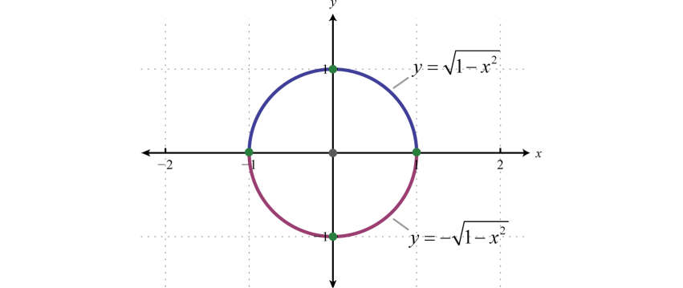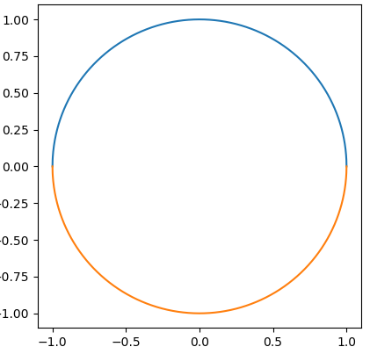

def plot_function(f, x_min = -10, x_max = 10, n_values = 2000):

plt.gca().set_aspect("equal")

x = np.linspace(x_min, x_max, n_values)

y = f(x)

plt.plot(x, y)

plot_function(lambda x: np.sqrt(1 - x**2), -1, 1)

plot_function(lambda x: -np.sqrt(1 - x**2), -1, 1)

plt.show()

import numpy as np

import matplotlib.pyplot as plt

r = 1 # Radius

phi = np.linspace(0, 2 * np.pi, 1000) # Angle (full circle)

x = r * np.cos(phi)

y = r * np.sin(phi)

plt.plot(x, y)

plt.gca().set_aspect("equal")

plt.show()

plt.polar(phi, r)

## 8. Complex Numbers

* History of number fields
  + **Natural numbers**: 
  + **Integers:** 
  + **Rational numbers  :** ratio of two integers
  + **Real numbers**: 
  + **Complex numbers**: 
    - "Imaginary unit":  is the positive solution of 
    - Pairs of real numbers: 
    - Commonly written as: 
    - **Real part**: 
    - **Imaginary part**: 
    - **In Python, we use j instead of i**

3 + 2j

1j

3j

* + - We can get the real and imaginary parts

z = 3 + 2j

print(z.real) # 3

print(z.imag) # 2

* + - Adding and multiplying complex numbers

print((3 + 2j) + (8 - 3j)) # (11-1j)

print((3 + 2j) * (8 - 3j)) # (30+7j)

* + We can plot the coordinate **pairs on the plane**
  + Polar form: $z=a+bi=ρ\left(\cos\left(φ\right)+i\sin\left(φ\right)\right)$

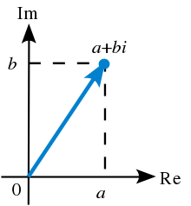

## 9. Euler's Formula

* Leonhard Euler proved that: 
  + Here's a [summary of the proof](http://mathworld.wolfram.com/EulerFormula.html)
  + It involves series which **we haven't covered yet**
  + A very beautiful consequence: 
* Now we can write our complex number as: 
* Why and how does multiplication work?
  + Multiplication by a real number
    - Scales the original vector
  + Multiplication by an imaginary number
    - Rotates the original vector
  + You can see a thorough explanation [here](https://betterexplained.com/articles/understanding-why-complex-multiplication-works/)
* **Main point:** Multiplication of complex numbers is the same as scaling and rotating 2D vectors

**10. Fundamental Theorem of Algebra**

* Theorem of Algebra: "**Every non-zero, single-variable, degree- $n$ polynomial with complex coefficients has, counted with multiplicity, exactly $n$ complex roots**."
* More simply said: **Еvery algebraic equation has as many roots as its power.**
* Back to quadratic equations
  + How do we get all roots?
  + Simply use the complex math Python module: **cmath**

import cmath

def solve_quadratic_equation(a, b, c):

discriminant = cmath.sqrt(b * b - 4 * a * c)

return [

(-b + discriminant) / (2 * a),

(-b - discriminant) / (2 * a)]

print(solve_quadratic_equation(1, -3, -4))

# [(4+0j), (-1+0j)]

print(solve_quadratic_equation(1, 0, -4)) # [(2+0j), (-2+0j)]

print(solve_quadratic_equation(1, 2, 1)) # [(-1+0j), (-1+0j)]

print(solve_quadratic_equation(1, 4, 5)) # [(-2+1j), (-2-1j)]

**11. Galois Field**

* In everyday algebra, we usually think about fields as those we already know
* But since algebra is abstract, we can define our own fields
* **Galois field:**

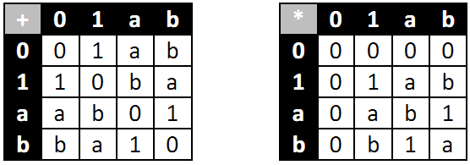

* + **Elements $\{0, 1\}$**
  + **Addition: equivalent to XOR**
  + **Multiplication: as usual**
* **Usage: in cryptography**
* If you're interested, you can have a look at [this](https://sites.math.washington.edu/~morrow/336_12/papers/juan.pdf) paper